***Illinois Association of Snowmobile Clubs, Inc***

PO Box 8171, Elburn, IL 60119 815-210-0587

[www.ilsnowmobile.com](http://www.ilsnowmobile.com) [iasc.illinois@gmail.com](mailto:iasc.illinois@gmail.com)

***Harry Kroll and Mel Blaurock***

***Memorial Award***

The Harry Kroll and Mel Blaurock Memorial Trophy is the oldest award presented by the IASC. It was initially named for the second president of the Northeastern Illinois Association of Snowmobile Clubs (region 1). Harry's two main pushes were to organize new clubs and to connect all of the club trails into a network. He was a dedicated snowmobiler. He would work evenings free repairing peoples snowmobiles so he would have someone to ride with on the weekends. That was back in the days where you had to carry a box of spare spark plugs just to be able to get back home. Everyone’s snowmobile suit was grease stained.

Mel Blaurock was Harry's friend and served as his vice president and continued to be involved with the local clubs after Harry's Death. Mel's name was added to the award when he passed away in 2020. Mel also believed in organizing snowmobile clubs and a snowmobile trail network. He was always talking to snowmobilers promoting the importance of snowmobile clubs, importance of trails and protecting the landowners. Mel worked with others to help the state of Illinois establish favorable snowmobile laws as well as a Safety Education Program. Mel was a regular at the NIASC, McHenry County Snowmobile Association (region 2) and IASC meetings and provided a wealth of information from the past.

The clubs of Region 1 sponsors the award and it is presented each year at the IASC convention banquet.

It is awarded to the person(s) that the delegates feel has done the most for the sport of snowmobiling in Illinois. One page nominating resumes are emailed to Don Schaefer by members. These are read at the annual meeting of the IASC and a secret vote is taken. The award recipient is announced at the Convention banquet in November.

Email your nomination by Oct 1st to Don Schaefer (dssschaefer@msn.com)

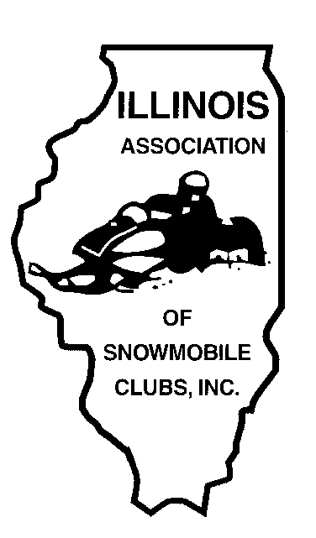

***Illinois Association of Snowmobile Clubs, Inc***

PO Box 8171, Elburn, IL 60119 815-210-0587

[www.ilsnowmobile.com](http://www.ilsnowmobile.com) [iasc.illinois@gmail.com](mailto:iasc.illinois@gmail.com)

***Harry Kroll / Mel Blaurock***

***Memorial Award***

Name of nominee:

The snowmobiler is a member of what snowmobile club(s)?

Please describe why you think this person should be nominated for the Harry Kroll / Mel Blaurock

Memorial Award:

____________________________________________________________________________________

____________________________________________________________________________________

____________________________________________________________________________________

____________________________________________________________________________________

____________________________________________________________________________________

____________________________________________________________________________________

____________________________________________________________________________________

**Submitted BY: _____________________________________ Email Address: __________________**

Send your nomination by Oct 1st to Don Schaefer (dssschaefer@msn.com)