# Illinois Association of Snowmobile Clubs

PO Box 8171, Elburn, IL 60119 815-210-0587

[www.ilsnowmobile.com](http://www.ilsnowmobile.com) [iasc.illinois@gmail.com](mailto:iasc.illinois@gmail.com)

***IASC Club of the Year***

There are great snowmobile clubs throughout Illinois! Each season the IASC sponsors a ***Club of the Year*** program intended to recognize an Illinois club that is involved and active at all levels. The *Club of the Year* Award recognizes a snowmobile club that demonstrates exceptional commitment to organized snowmobiling, active involvement with snowmobile organizations, and a dedication to making the sport enjoyable for members and the broader snowmobiling community.

The IASC winner is submitted to the ACSA competition for Snowmobile Club of the Year where Snowmobile clubs from all 27 snowmobile states are judged. The ACSA Club of the Year is announced at the annual International Snowmobile Congress held in June.

The IASC Club of the Year is featured in the the *Illinois Snowmobiler.* They will be invited guests to the annual IASC Convention Banquet in November, at which time they will receive a recognition award.

**Club of the Year Nomination Form**

Nominations may be submitted by IASC member snowmobile clubs or individual IASC/Club members. The following **OFFICIAL NOMINATION FORM MUST BE USED**. All nominations should include a cover letter offering some insight into why you feel your nominee should be chosen and pictures supporting your nominee. Also include the nominee’s full name, address, a description of the nominee and their contributions to snowmobiling, as well as an explanation as to why these contributions are particularly noteworthy.

Please submit original nominations by **Oct 1st**

All nominations should be submitted to:

[iasc.illinois@gmail.com](mailto:iasc.illinois@gmail.com)

*Disclaimer Region and Alliance organizations are not eligible for this award, nominations should

be for individual clubs only.

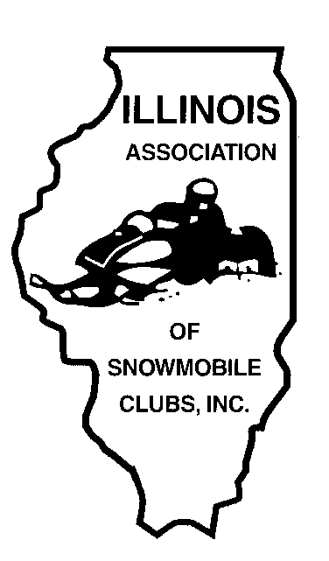

# Illinois Association of Snowmobile Clubs

PO Box 8171, Elburn, IL 60119 815-210-0587

[www.ilsnowmobile.com](http://www.ilsnowmobile.com) [iasc.illinois@gmail.com](mailto:iasc.illinois@gmail.com)

***IASC Club of the Year Nomination Form***

Snowmobile Club name and address

Name and address of sponsor _____________________________________________________________________

How many members are currently in the club? ________________________________________________________

Has the membership increased over the past year? _____________________________________________________

Describe how your club promotes membership to new people:___________________________________________

__________________________________________________**___________________________________________**

**_____________________________________________________________________________________________**

How long has the club been active?________________________________________________________________

Does your club have a website? ___________________________________________________________________

Website Address:_______________________________________________________________________________

Does your club groom trails?______________________________________________________________________

If Yes, explain:_________________________________________________________________________________

_____________________________________________________________________________________________

Describe any local, regional, state, or national government meetings or legislative activities in which the club has been

an active participant in. ___________________________________________________________________________

______________________________________________________________________________________________

Name and Explain how the club participates in club and association fund raising events. The fundraising does not have

to be restricted to snowmobiling. ____________________________________________________________________

_______________________________________________________________________________________________

Does your club have any partnerships with other organizations?____________________________________________

If Yes, explain: __________________________________________________________________________________

_______________________________________________________________________________________________

Describe how the club represents snowmobiling and snowmobilers at club, regional, state, and national activities:____

_______________________________________________________________________________________________

_______________________________________________________________________________________________

Describe how the club promotes safe and responsible riding for members and non-members:_____________________

_______________________________________________________________________________________________

_______________________________________________________________________________________________

Describe the methods your club uses to introduce non-snowmobiliers to the sport:_____________________________

______________________________________________________________________________________________

______________________________________________________________________________________________

Outline any activity(s) the club has done in the past year to promote a positive image of snowmobiling:___________

______________________________________________________________________________________________

______________________________________________________________________________________________

What are the three most important events organized by your club in the last 2 riding seasons?___________________

_____________________________________________________________________________________________

_____________________________________________________________________________________________

What distinguishes this club from other clubs?_______________________________________________________

____________________________________________________________________________________________

____________________________________________________________________________________________

What one special thing should we know about your club? ______________________________________________

____________________________________________________________________________________________

____________________________________________________________________________________________

**PLEASE RETURN COMPLETED FORM ALONG WITH YOUR CONTACT INFORMATION TO: IASC.Illinois@gmail.com**

*All forms must be submitted to the IASC office by Oct 1st*

You are not limited to these eligibility requirements or the space provided for filling out your nominations. Photos and press clippings may be sent to us as well. (All materials cannot be returned.)