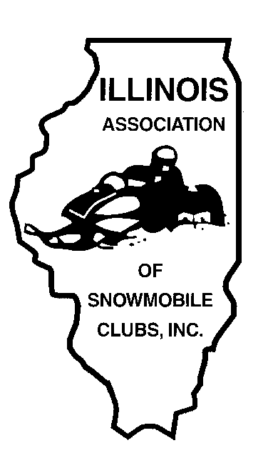
Illinois Association of Snowmobile Clubs
PO Box 8171, Elburn, IL 60119 815-210-0587
www.ilsnowmobile.com iasc.illinois@gmail.com

IASC Dealer of the Year

There are great snowmobile dealerships throughout Illinois! It takes more than just selling a lot of sleds to make a great dealership--its true dedication to the sport and the customers they serve that make them stand out above the rest. Each season the IASC sponsors a Dealer of the Year program intended to recognize an Illinois dealership that is involved and active at all levels, customer, organization, and overall total support of snowmobiling. The IASC winner is submitted to the ACSA competition for Snowmobile Dealer of the Year where dealers from all 27 snowmobile states are judged. The ACSA Dealer of the Year is announced at the annual International Snowmobile Congress held in June.

The IASC Dealer of the Year is featured in the the Illinois Snowmobiler. They will be invited guests to the annual IASC Convention Banquet in November, at which time they will receive a recognition award.

Dealer of the Year Nomination Form

Nominations may be submitted by IASC member snowmobile clubs or individual IASC/Club members. The following OFFICIAL NOMINATION FORM MUST BE USED. All nominations should include a cover letter offering some insight into why you feel your nominee should be chosen and pictures supporting your nominee. Also include the nominee’s full name, address, a description of the nominee and their contributions to snowmobiling, as well as an explanation as to why these contributions are particularly noteworthy.

Please submit original nominations by Oct 1st
All nominations should be submitted to:
iasc.illinois@gmail.com

Illinois Association of Snowmobile Clubs
PO Box 8171, Elburn, IL 60119 815-210-0587
www.ilsnowmobile.com iasc.illinois@gmail.com

IASC Dealer of the Year Nomination Form
Dealership name and address

Name and address of sponsor

The dealer is an active member of what snowmobile club(s)

How many years has the dealer been active in organized snowmobiling?

Describe leadership positions and dates of activity the dealer holds and has held in a club, region, state, or national snowmobile association

Describe what local, regional, state and national government meetings where the dealer has been an active participant.

Name and explain how the dealer participates in club and association fund raising events. The fundraising does not have to be restricted to snowmobiling

Describe does the dealer represents snowmobiling and snowmobilers at club, regional, state, and national activities.

Explain how the dealer is involved in all phases of snowmobiling.

Describe the methods your nominee uses to introduce non-snowmobilers to the sport.

Describe how and when does the dealer introduce customers to organized snowmobiling.

Describe how the dealer promotes club membership.

Describe any special projects the dealer currently participates in.

PLEASE RETURN COMPLETED FORM ALONG WITH YOUR CONTACT INFORMATION TO: IASC.Illinois@gmail.com
All forms must be submitted to the IASC office by Oct 1st
You are not limited to these eligibility requirements or the space provided for filling out your nominations. Photos and press clippings may be sent to us as well. (All materials cannot be returned.)

